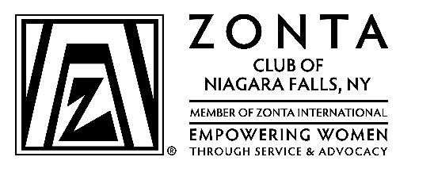
Your logo here

Social Media Release Form
1,hereby grant permission to the Zonta Club of YOUR NAME HERE and Zonta International (ZI) and its assigns and licensees to take photographs or videos of me, and to make recordings of my voice. I give the Zonta Club of YOUR CLUB NAME HERE and ZI permission to use these images, videos, and recordings, as well as my likeness, name, and voice, as follows:
•The use may include reproduction, distribution, derivative works, display, and performance. •The use may be in composite or modified forms and in any media, now known or later developed, including without limitation newspapers, television, radio, the World Wide Web, and social media.
•The use may be for any purpose throughout the world and in perpetuity, including, without limitation, education, trade, advertising, and promotion.
I further acknowledge that I will not be compensated for these uses, and that the Zonta Club of YOUR CLUB NAME HERE and ZI exclusively owns all rights to the images, videos, and recordings, and to any derivative works created from them.
I waive the right to inspect or approve of the uses of any printed or electronic copy.
I hereby release the club and ZI and its assigns and licensees from any claims that may arise from these uses, including without limitation claims of defamation or invasion of privacy, or of infringement of moral rights or rights of publicity or copyright.
This Release is binding on me, my heirs, assigns and estate. The Zonta Club of YOUR CLUB NAME HERE and ZI are not obligated to use any of the rights granted under this Release.
This Release expresses the complete understanding of the parties.
I acknowledge that my name and identity may be revealed in the use of this data or by descriptive text or commentary. However, The Zonta Club of YOUR CLUB NAME HERE nor ZI may not publish my address, telephone numbers, or email address with the Product without my permission.

Name (Printed) Phone

Address City Province/State Postal Code/Zip Code

Signature Date

